**R Code for Examples in the book**

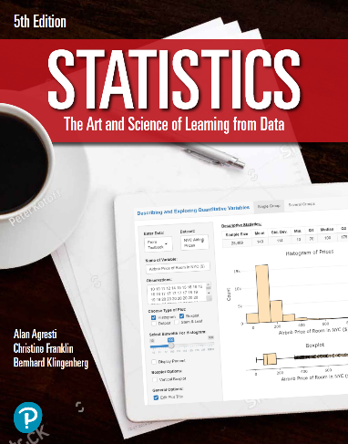

***“Statistics: The Art and Science of Learning from Data”***

**by Agresti, Franklin and Klingenberg, 5th edition**

**Chapter 2**

**Example 11: CO2 Pollution – Mean, Median, and Outliers**

## Read in CO2 pollution values:

co2 <- c(5.9, 1.8, 0.3, 1.4, 2.1, 0.4, 16.9, 0.8, 11.6)

## To find the Median:

median(co2)

## [1] 1.8

## Create Dotplot:

stripchart(co2, method = 'stack', pch=19, frame.plot=FALSE,   
 xlim = c(0, 20), ylim = c(0,3),   
 main = 'Dotplot',   
 xlab = expression('Per Capita CO'[2]*  
 ' Emissions (in metric tons)'))

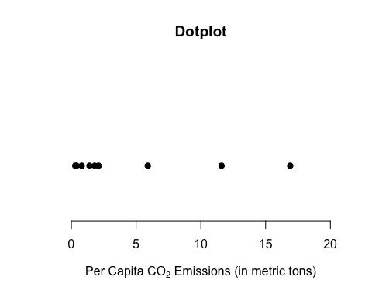

## A slightly better dotplot can be obtained with the ggplot2 library. To install it, type install.packages(ggplot2).

library(ggplot2)  
ggplot(data.frame(co2), aes(x = co2)) +   
 geom_dotplot(binwidth = 0.1, dotsize = 4) +  
 labs(x = expression('Per Capita CO'[2]*' Emissions (in metric tons)'),   
 title = 'Dotplot', subtitle = expression('CO'[2]*' Pollution')) +  
 theme_classic() +  
 theme(axis.line.y=element_blank(),  
 axis.text.y=element_blank(),  
 axis.ticks.y=element_blank(),  
 axis.title.y=element_blank()  
 )

